

Thrivewelltech Data Engineering and Analytics Solution for Westminster Richmond and Brio Customers

Introduction
ThriveWell Tech is dedicated to providing comprehensive data engineering and analytics solutions to its clients. This document outlines our approach to developing data solutions for our clients, Westminster Canterbury Richmond (WCR) and Brio Living Services, detailing the architecture, ETL processes, current client data sources, reporting capabilities, new customer onboarding, and upcoming projects.

Purpose
The purpose of this documentation is to provide an internal guide on the data engineering and analytics solutions we offer to Westminster and Brio customers. It covers our data architecture, ETL processes, client-specific data sources, reporting capabilities, onboarding processes, and details for upcoming new customers.

Our Data Architecture
Our data architecture is designed to handle large volumes of data from various sources, ensuring high performance, scalability, and reliability. The architecture consists of the following components:
- Amazon Redshift: A fully managed data warehouse service used for storing and querying large datasets.
- AWS Glue: A fully managed ETL service that helps in extracting, transforming, and loading data into the data warehouse.
- Amazon S3: A scalable storage service used for storing raw and processed data.
- Apache Spark: A unified analytics engine for large-scale data processing.
- Amazon QuickSight: A business intelligence service for creating and publishing interactive dashboards and reports.

Components of the Architecture
- Amazon Redshift: Provides a high-performance, scalable data warehouse for storing and querying large datasets efficiently.
- AWS Glue: Facilitates the extraction, transformation, and loading (ETL) of data from various sources into Redshift, ensuring data quality and consistency.
- Amazon S3: Stores raw and processed data, serving as a data lake for our architecture.
- Apache Spark: Processes large datasets quickly and efficiently, enabling complex data transformations.
- Amazon QuickSight: Allows for the creation and sharing of interactive dashboards and reports, making data accessible to stakeholders.

ETL: How Our ETL Works
Our ETL process involves extracting data from multiple sources, transforming it to ensure consistency and quality, and loading it into our data warehouse. This process includes:
- Identification: Determining relevant data sources and understanding the data structures.
- Extraction: Using connectors or custom scripts to pull data from source systems.
- Transformation: Cleaning, standardizing, and enriching the data using tools like Apache Spark.
- Loading: Ingesting the transformed data into Amazon Redshift for storage and querying.

Current Clients Data Sources

Westminster Canterbury Richmond (WCR)
- MatrixCare: Provides clinical and administrative data.
- UKG Ultipro: Supplies HR and payroll data.
- Sage Intacct: Offers financial data.

Brio Living Services
- PointClickCare (PCC): Clinical and administrative data.
- SAGE: Financial data.
- PCO for PACE: New integration for clinical data.
- ADP: New integration for HR and payroll data.
- MatrixCare for Home Health and Hospice: New integration for clinical data.

Reports We Build

At ThriveWell Tech, we specialize in developing a variety of reports tailored to meet the diverse needs of our clients. These reports provide critical insights into operational, financial, and clinical aspects of their organizations, enabling data-driven decision-making. Below is a detailed explanation of the common reports we build for our clients:
- Daily Occupancy Report:
  - Purpose: To provide an up-to-date snapshot of occupancy levels within the facility.
  - Content: This report includes metrics such as the total number of occupied units, available units, and occupancy rate. It can be broken down by different types of units (e.g., assisted living, independent living, skilled nursing).
  - Usage: Facility managers use this report to monitor daily occupancy trends, optimize space utilization, and forecast future occupancy needs.
- Headcount Report:
  - Purpose: To track the number of employees within the organization.
  - Content: This report details the total headcount, including full-time, part-time, and temporary staff. It may also include departmental breakdowns, employee demographics, and turnover rates.
  - Usage: HR managers utilize this report to manage staffing levels, plan recruitment activities, and analyze workforce trends.
- Operating Ratio Report:
  - Purpose: To evaluate the financial performance of the organization.
  - Content: The report includes key financial ratios such as the operating margin, expense ratio, and revenue per unit. It provides a comprehensive view of the organization's financial health.
  - Usage: Financial analysts and executives use this report to assess profitability, identify cost-saving opportunities, and make informed budgetary decisions.
- Payer Mix Report:
  - Purpose: To understand the distribution of revenue sources.
  - Content: This report breaks down revenue by payer type, including private pay, Medicare, Medicaid, and other insurance providers. It shows the proportion of revenue from each payer and trends over time.
  - Usage: Financial planners and billing departments use this report to optimize billing practices, negotiate with payers, and forecast revenue streams.
- Case Mix Index (CMI) Report:
  - Purpose: To measure the complexity and resource needs of the patient population.
  - Content: The CMI report provides a weighted average of the acuity levels of patients, reflecting the intensity of care required. It includes details on patient diagnoses, treatments, and length of stay.
  - Usage: Clinical managers and financial officers use this report to plan staffing needs, allocate resources effectively, and adjust reimbursement strategies based on patient acuity levels.
- HR Recruitment Report:
  - Purpose: To track and manage recruitment activities.
  - Content: This report includes metrics such as the number of job openings, applications received, time-to-fill positions, and recruitment costs. It may also provide insights into the effectiveness of different recruitment channels.
  - Usage: HR departments use this report to streamline the hiring process, reduce recruitment costs, and improve the quality of hires.
- Hospital Readmissions Report:
  - Purpose: To monitor and reduce hospital readmission rates.
  - Content: This report details the number of readmissions within a specified period, reasons for readmissions, and patient demographics. It may also include trends and patterns in readmission rates.
  - Usage: Healthcare providers use this report to identify high-risk patients, develop intervention strategies, and improve overall patient care quality to reduce readmissions.

Sample Screens of Each Report

To provide a clear visual understanding, we create interactive dashboards using tools like Amazon QuickSight or data visualization features in Amazon Redshift. Below are descriptions of what each report screen might include:
- Daily Occupancy Report Screen:
  - A dashboard showing real-time occupancy rates with graphical representations (e.g., bar charts, pie charts).
  - Filters to view occupancy by unit type, date range, and facility location.
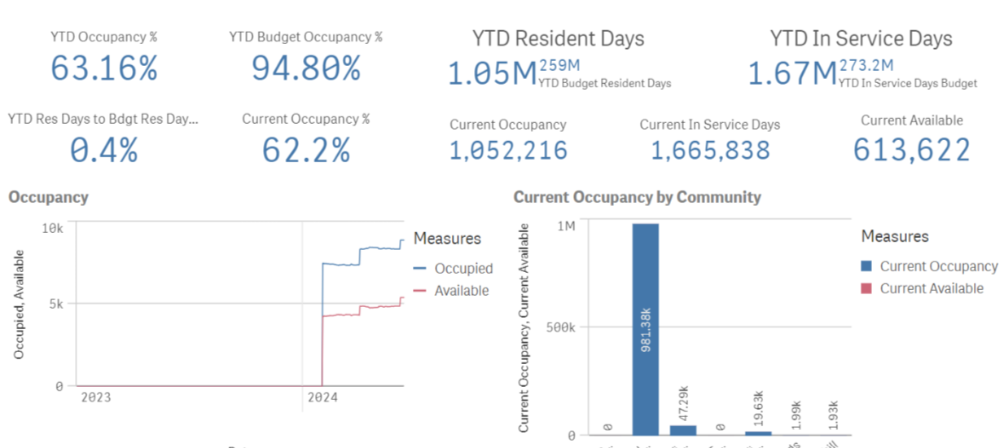

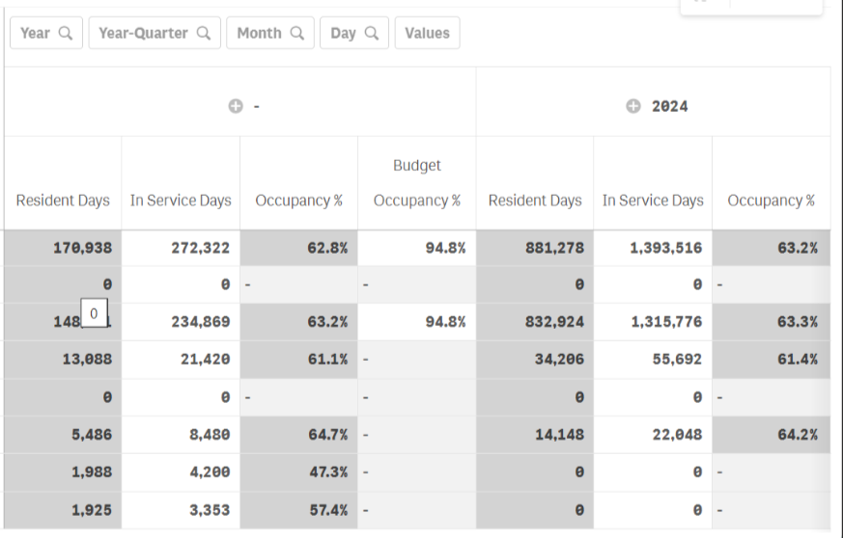
- Headcount Report Screen:
  - A table listing employee counts by department, along with visual charts showing headcount trends over time.
  - Interactive features to drill down into specific demographic details (e.g., age, gender, employment type).

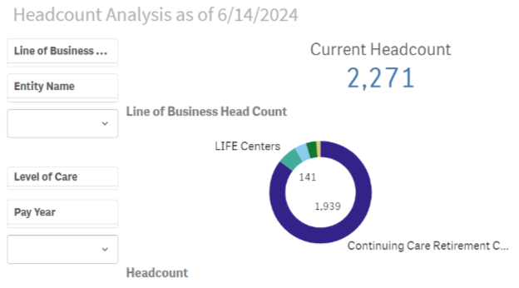

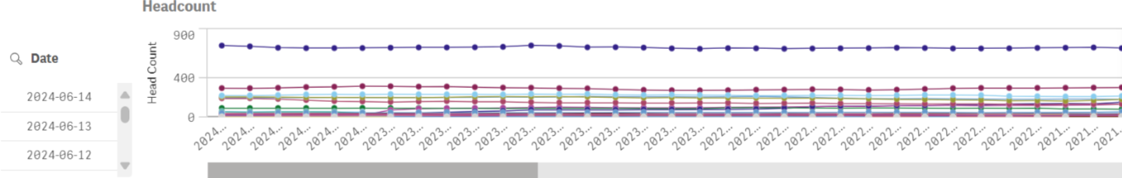
- Operating Ratio Report Screen:
  - Graphs displaying key financial ratios over selected periods.
  - Comparison features to benchmark against industry standards or previous periods.
- Payer Mix Report Screen:
  - Pie charts or bar graphs showing the distribution of revenue by payer type.
  - Trends over time with options to filter by specific payers or time frames.

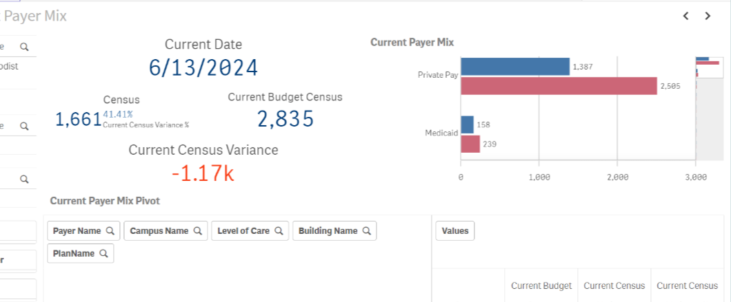
- Case Mix Index (CMI) Report Screen:
  - Charts showing patient acuity levels and CMI trends.
  - Detailed tables with patient information, diagnoses, and treatment details.
- HR Recruitment Report Screen:
  - Graphical representations of recruitment metrics (e.g., number of applications, time-to-fill).
  - Interactive elements to analyse recruitment channels and costs.
- Hospital Readmissions Report Screen:
  - Charts showing readmission rates, reasons for readmissions, and patient demographics.
  - Trend analysis tools to identify patterns and high-risk groups.

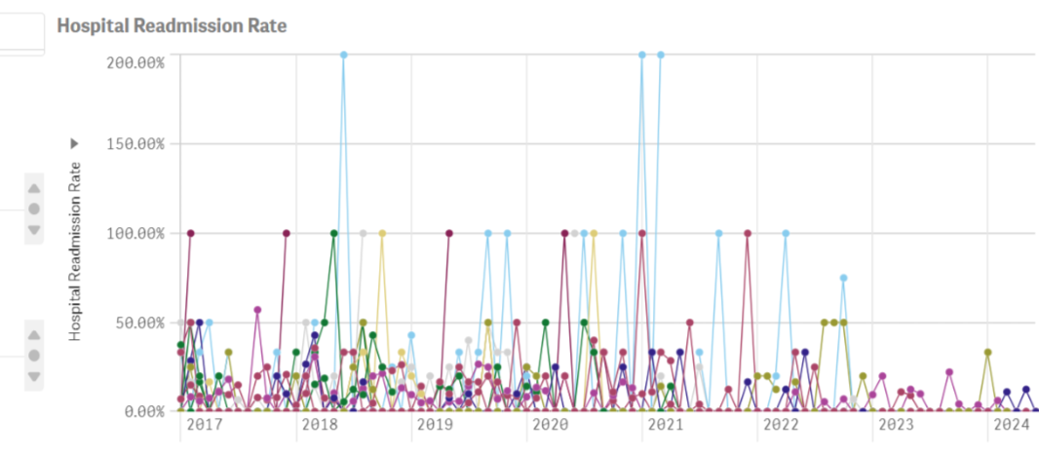

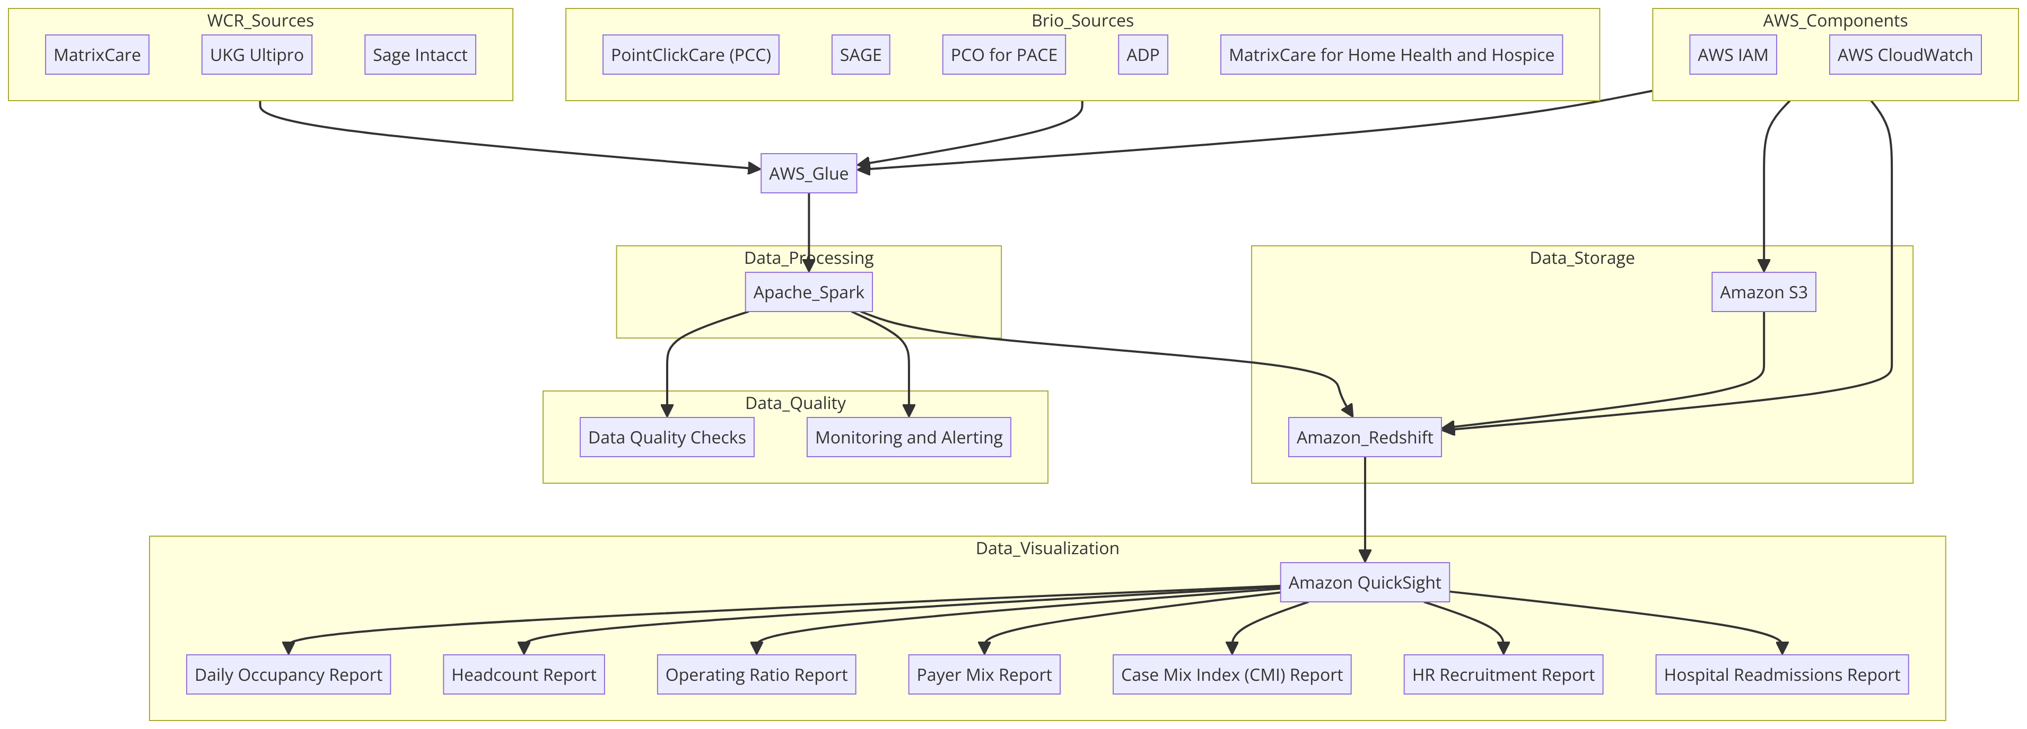

Sample Screens of Each Report
Screenshots and examples of these reports can be created using tools like Amazon QuickSight or Redshift. Each report is designed to provide clear, actionable insights to our clients.

New Customer Onboarding Process
- Initial Consultation: Understanding the client's data needs and requirements.
- Data Source Identification: Identifying and analyzing relevant data sources.
- ETL Pipeline Setup: Setting up the extraction, transformation, and loading processes.
- Report Development: Creating initial reports and dashboards.
- User Training: Providing training to end-users on how to use the reports.
- Maintenance and Support: Ongoing support and maintenance of the data solutions.

Next Upcoming New Customers

Brio Living Services
- Data Sources: PCC, SAGE, PCO for PACE, ADP, MatrixCare for Home Health and Hospice.
- Reports: Daily Occupancy, Headcount, Operating Ratio, Payer Mix, HR Recruitment, Hospital Readmissions, HR Budget to Paid Earnings.
- Timeline: Planned to start on 01-Jul-2024, with an estimated completion time of 6 months.
- Work Breakdown and Timelines:
  - Requirements Gathering: 3 weeks
  - Data Integration: 3 weeks per data source
  - Report Development: 2 weeks per report
  - Quality Assurance and Deployment: 2 weeks per report

Westminster Canterbury Richmond
- Data Sources: MatrixCare, UKG Ultipro, Sage Intacct.
- Reports: Daily Occupancy, Headcount, Operating Ratio, Payer Mix Index (PMI), Case Mix Index (CMI), HR Recruitment, Hospital Readmissions.
- Timeline: Estimated to start on June 1st, with an estimated completion time of 8 months.
- Work Breakdown and Timelines:
  - Requirements Gathering: 4.5 weeks
  - Data Integration: 4 weeks per data source
  - Report Development: 1 month per report
  - Quality Assurance and Deployment: 1 month

Our ETL and Report Development Process
- Identify: Determine the data sources and reporting requirements.
- Map: Understand the data structures and map the data fields.
- Extract: Pull data from source systems.
- Transform: Clean, standardize, and enrich the data.
- Validate: Ensure data accuracy and quality.
- Report: Develop and deploy reports and dashboards.
- UAT: Conduct user acceptance testing.
- Handoff: Provide training and documentation to end-users.

Key Resources for This Project
- Project Manager: Oversees the project, ensuring timely delivery and communication.
- Data Engineers: Handle data extraction, transformation, and loading processes.
- Data Analysts: Work on data analysis and report development.
- Quality Assurance: Ensure data accuracy and report quality.
- Support Team: Provide ongoing maintenance and support.

Escalation Matrix
- Level 1: Project Manager
- Level 2: Data Engineering Lead
- Level 3: Director of Data Science
- Level 4: CTO

Version Control
All project artifacts, including code, documentation, and reports, will be managed using a version control system (e.g., Git) to ensure proper tracking of changes and collaboration among team members.
This document provides a comprehensive overview of our data engineering and analytics solution approach for Westminster and Brio customers, ensuring all team members are aligned and informed on the project processes and expectations.

Communication Plan

RACI Chart

